World premiere: DMU 65/75 monoBLOCK 2nd Generation
Optimized components for even more performance: Even in the second generation, the monoBLOCK series from DMG MORI stands for versatility, ergonomics, and precision.

monoBLOCK: the original sets new standards

After more than 6,000 installed machining centers of the monoBLOCK series, DMG MORI now presents the second generation of the successful machine concept. The new DMU 65 monoBLOCK 2nd Generation as well as the package machine DMU 75 monoBLOCK 2nd Generation appear in the ergonomic stealth design and impress with a 20 percent optimized temperature stability and accuracy with a positioning accuracy of 4 µm in the linear axes. Level 4 connectivity with IO-Link sensors and preparation for an automation interface are already on board as standard. These measures make the machine maximally future-proof.
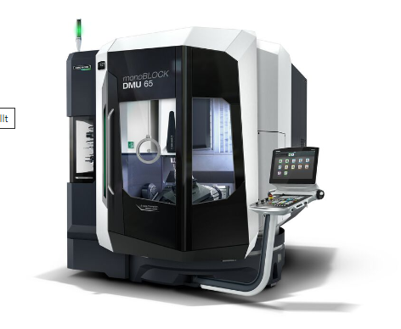
Optimized components for even more machining quality: Even in its second generation, the monoBLOCK series from DMG MORI stands for versatility, ergonomics and precision.

In the further development of the monoBLOCK concept, DMG MORI has remained true to the strengths of the predecessor machines: Ergonomics, versatility and precision also characterize the new DMU 65/75 monoBLOCK 2nd Generation. The optimization of the monoBLOCK concept lies primarily in the components that are instrumental in ensuring high-precision machining. The ball screws of the X and Y axes are directly driven and feature extensive cooling measures, while the helical gear train of the torsionally stiff NC swivel rotary table ensures optimum surfaces even in continuous operation. In addition, thermosymmetrical cooling of the slide reduces inaccuracies. Temperature stability has been increased by 20 percent as a result of the improvements.

Ergonomic design and innovative control technology
To ensure full compatibility with the previous generation, the DMU 65/75 monoBLOCK 2nd Generation have an identical working area of 735 x 650 x 560 mm or 750 x 650 x 560 mm. Externally, the high-quality and durable cabin in stealth design stands out. Straight viewing panels here ensure a perfect view into the working area. IO-Link sensors also provide optimum monitoring and control of the machining process.

Modular system for maximum flexibility
DMG MORI also relies on proven technology for the tool magazine. The chain magazine of the DMU 65 monoBLOCK 2nd Generation offers space for 30 tools as standard. Optionally, up to 240 places are now available with the second Generation. The magazine has a sliding door that opens upwards, so that the space requirement here is significantly reduced. In addition, the monoBLOCK modular system continues to offer a wide range of motor spindles with up to 400 Nm of torque or a speed of up to 30,000 rpm. The chip conveyor has also been optimized. The Zero Sludge System of the chip conveyor improves the cleaning of the cooling lubricant and reliably frees it from chips. The DMU 75 monoBLOCK 2nd Generation was again designed as a complete package. It is equipped with a speedMASTER SK 40 motor spindle. 20,000 rpm and 130 Nm offer a perfect balance between speed and torque. Its tool magazine has 60 places as standard. Added to this is optimum protection of the machine through quick shutdown thanks to Machine Protection Control (MPC).

Versatile automation range
Thanks to an automation cabin and 4-channel rotary feed-through as standard, the DMU 65/75 monoBLOCK 2nd Generation is perfectly prepared for a retrofit of the automation interface and thus optimally equipped for future requirements in production. Flexible pallet handling systems such as the PH Cell or the PH 150 as well as the versatile Robo2Go Milling or the PH-AGV driverless transport system can be easily offered and increase the productivity of the machines in unmanned night and weekend shifts.

